Who are we at Hilltop Home:  Hilltop Home is a private, nonprofit Intermediate Care Facility in Raleigh, North Carolina that serves children with severe to profound developmental disabilities who are medically fragile. For 60 years and counting, our mission is to provide exceptional, individualized, 24/7 care in a nurturing, home-like environment, grounded in the belief that every child deserves safety, dignity, love, and opportunities to thrive. From birth through adulthood, we tailor care to each individual’s medical, developmental, and educational needs.  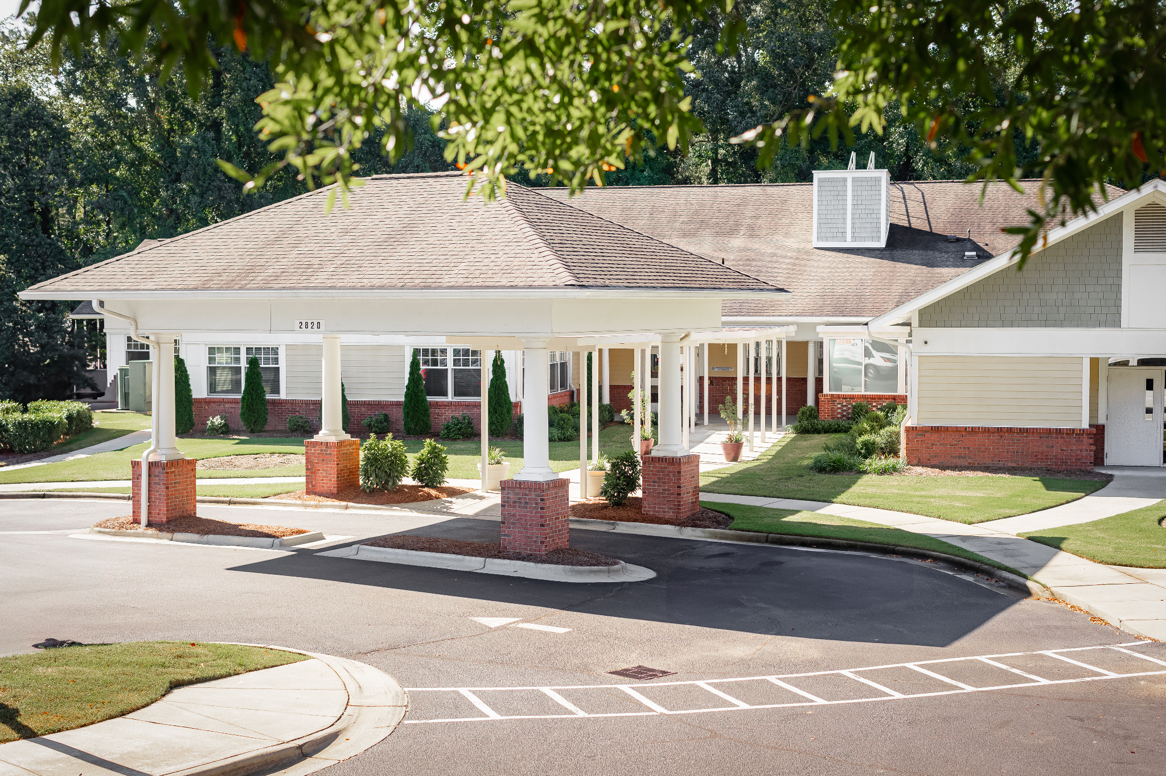  Hilltop Home offers comprehensive services including around-the-clock licensed nursing care, personalized medical support, therapeutic services, and a certified educational program. Our multidisciplinary team collaborates to create habilitative care plans while partnering with families, donors, and the community to enhance quality of care, promote social and emotional well-being, and encourage meaningful participation in activities throughout the Raleigh community. | 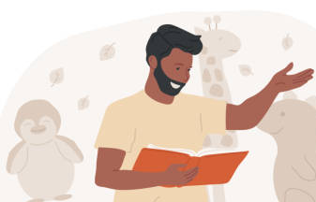  Your creativity, passion, talent, and heart create connection…  Let’s have fun along the way!  Joy looks like community – community volunteers play a vital role in promoting social participation, inclusion, and belonging to our residents.    This allows for our residents to gain consistent, positive community interaction, while programs like yours can gain hands-on service experiences, leadership development, and alignment with their mission to serve others.  Partnering with Hilltop Home allows community programs to make a meaningful impact while strengthening leadership, service, and real-world engagement.    Together, we promote inclusion, connection, and belonging. | Big smiles, shared laughs, and meaningful moments start here:  Due to the complex medical needs of our residents that require specialized care from trained professionals, volunteer opportunities are thoughtfully designed to support our staff’s work without involving direct handling.  We thank you for your understanding!  How you can volunteer:  - Perform live music or dance routines  - Lead sing-alongs or read stories  - Facilitate arts and craft projects  - Help plan community or holiday celebrations  - Play games with the use of assistive technology and switches  - Provide sensory stimulation experiences, e.g. visual or tactile displays, art shows, etc.  - Aid with facility management and gardening    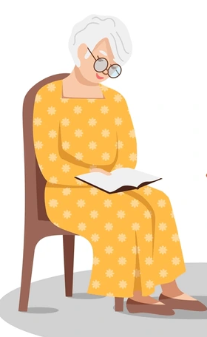  - Assist with organizing and supervising outdoor activities, fundraising, and advocacy per executive direction

Come as you are…  Bring your ideas,  leave with connections!  Volunteers play a vital role in enhancing our residents’ quality of life through activities like community engagement, event support, and creative projects. If you have other ideas of volunteering that were not listed, please reach out!  Who can get involved:  - Students and academic institutions  - Faith-based, spiritual, or cultural organizations  - Religious beliefs should not be promoted  or imposed onto the children or staff.  We appreciate your understanding.  - Performing arts companies  - Museums and nature centers  - Anyone organization or volunteer  interested in supporting our mission!  When can you volunteer?  - Weekday business hours (see back)  How to get in touch:        - Complete the contact form found on our website: https://hilltophome.org/Contact-Us | Together, we create a community where every child is valued, connected, and supported.  Other ways you can partner with Hilltop Home:  - Become a sponsor  - Donate from our Amazon Wish List or a monetary contribution (found on our website)    Contact us:  - Email: services@hilltophome.org  - Phone: (919) 231-8315  - Business Hours:  - Monday-Friday, 8am-5pm  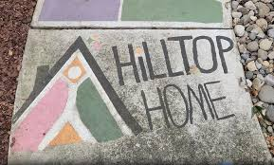  Reference and Website:  Hilltop Home (n.d.). from https://hilltophome.org/ | Joy grows when we create moments together at      Join our community in building meaningful relationships and memories with children while supporting their social, emotional, and developmental growth.        

