Accessible VaLend Powerpoint Titled: Intersectionality of Blindness and Neurodivergence.

Side 1: Intersectionality of Blindness and Neurodivergence.

Dawn Snow

Slide 2: Project Motivation.

* My Girls.
* Observations.
* Experiences shared by students and families.
* Personal Experiences.
* Violation of civil liberties.

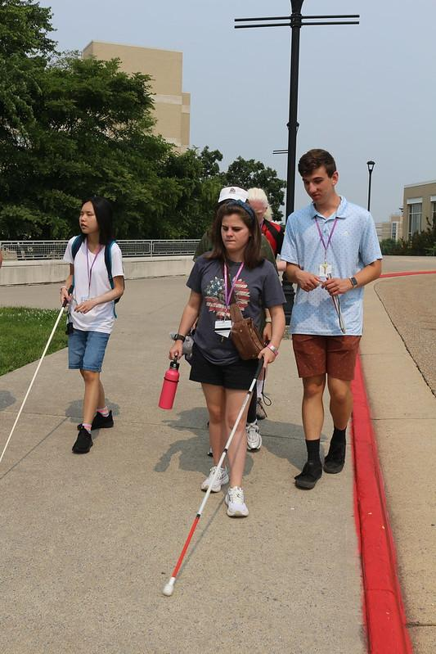 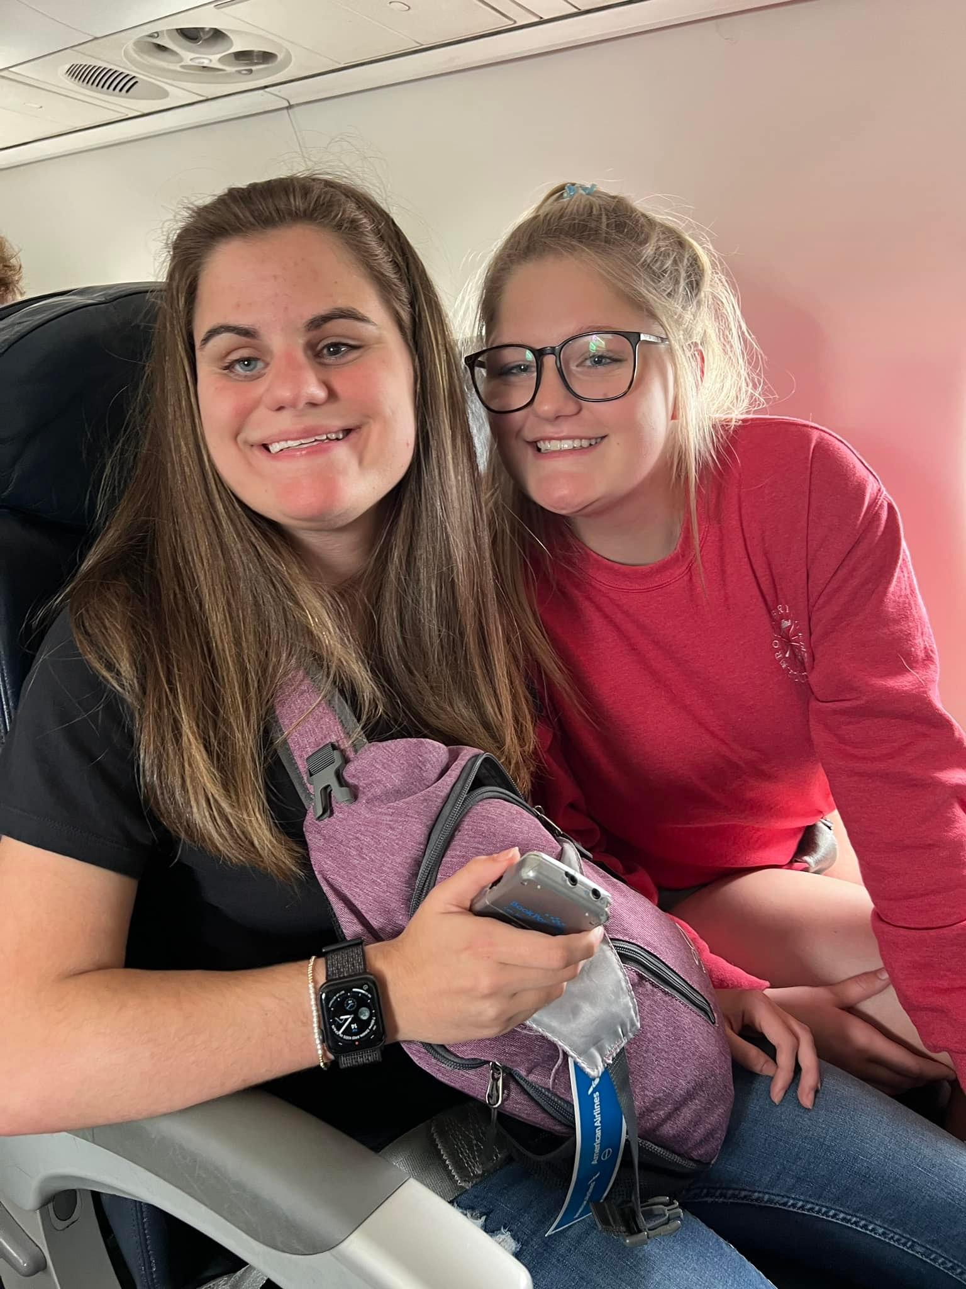

Slide 3: PROJECT.

* Part I:
  + Establish a focus group.
  + Establish a community of support.
  + Identify areas of need.
* Part II:
  + Continue Community of Support.
  + Create Video Series.
  + Lived experiences.
  + Resources.



Slide 4: Prevalence.

* “the relationship between autism and visual impairment is a close relationship;
* Data from epidemiological studies show that there are some causes of total and partial blindness that have a closer relationship with ASD:
  + retinopathy of prematurity (ROP),
  + Leber’s amaurosis,
  + optic nerve hypoplasia,
  + septo-optic nerve dysplasia,
  + micro-ophthalmia,
  + anophthalmia, and
  + CHARGE syndrome”
* More research needed.

(Pili R, 2021)

Slide 5: Prevalence cont.

* Approx. 50% of VA’s students with visual impairments have at least one coexisting disability.: (Virginia Department of Education, 2017)
* 50-75% of children with visual impairments have additional disabilities. (Silberman, 2000)
* Professional estimate at least 50% of students with visual impairments have additional disabilities and are not identified as having a visual impairment. There are differences between the Child Count and states’ total population counts. (Schles, 2021)

Often not captured in data counts as having a visual impairment:

* Students with visual impairments that have more complex needs are often identified as multiple disabilities.
* Students who are identified as Deafblind have a separate data count.

Slide 6: Excluded from VR and Pre-ets.

* Observation: VA’s Pre-ets and VR for the blind seem to focus on students who are blind without additional disabilities or support needs.
* Observation: Many students that participate have residual vision.

Data reflect:

* 2020 Study on VR Data about People with Visual Impairments:
  + “Virginia has the lowest rates of additional impairments,”
  + 6.8% “Priority of the disabling conditions qualifying the participant for services. In particular, the proportion of individuals in the data who are labeled with a “most significant disability” (C. M. Clapp, 2020)



Slide 7: Excluded from VR.

* Past:
  + Staff hand selected which students notified of opportunities.
* Current:
  + screening applicants for pre-ets programs. (Impaired D. f., 2024)
  + Non flexible criteria for VR program. Required to be independent in all self care. (Impaired V. R., 2024)

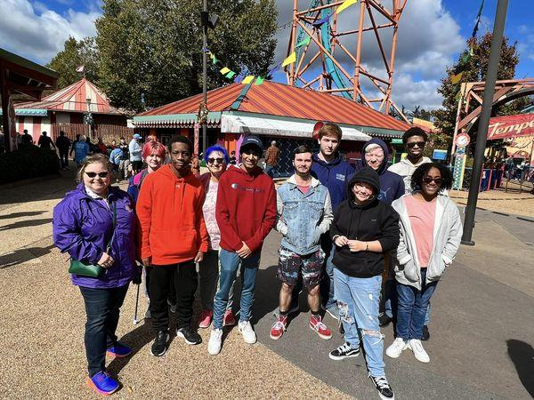

Slide 8: Excluded from VR and Training Centers.

Reported by families and students:

* Inflexible - Not person centered
* No exceptions to residential
* Sleep Shades
* Different Cane
* Structured Discovery Method (with minimal structure) (Board, 2008-2024)
  + Lots of concerns shared by students and families around this method.

Other Points to consider:

* Surveys are not utilized (Chaz Compton, 2022)
* Concern/Complaint form or procedures not easily available

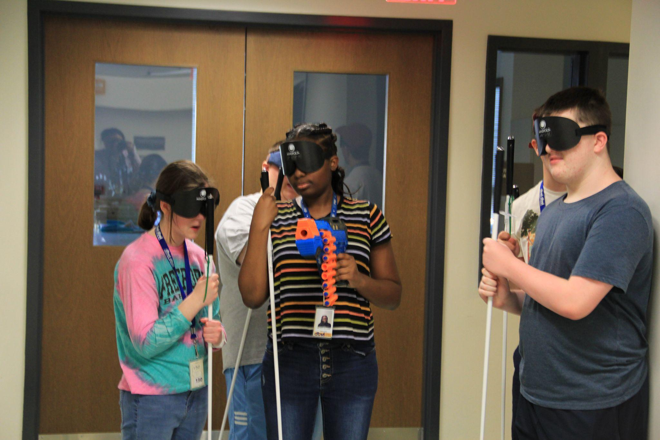

Slide 9: Quotes From Focus Group

* “I wish they would be more flexible.” - M.M.
* “They need to truly listen and learn from the youth.”-M.W.
* “Staff needs to work on their emotional intelligence.” -M.W.
* “Don’t yell at or humiliate us, be supportive.” - L.H.
* “There are different levels of independence and what works for one might not be right for another.” - K.D.
* “We are individuals with different needs and preferences.” - B.P.
* “What would they do if a blindness program said you couldn’t bring your cane? It is no different. A cane is a needed support just like a PCA is a needed support. It is a double standard.” -B.F.

Slide 10: Project HOPES – GOALS.

* Raise awareness
* Change in attitudes
* Normalize neurodiversity within the blind community & professionals
* Increase family/student advocacy
* Encourage agencies and organizations to implement trainings
  + Inclusion
  + Neurodiversity
  + Trauma Informed Care
  + Person Centered Practices
* Impact how agencies and organizations support students.

Slide 11: References.

* Board, N. B. (2008-2024). What is Structured Discovery. Retrieved from National Blindness Professionals Certification Board: https://www.nbpcb.org/pages/what-is-structured-discovery.php#:~:text=SDCT%20is%20now%20a%20unique,learning%2C%20and%20confidence%20building%20experiences.
* C. M. Clapp, J. V. (2020). Overview of Vocational Rehabilitation Data about People with Visual Impairments: Demographics, Services, and Long-Run Labor Market Trends. Journal of Visual Impairments & Blindness, 114(1), 43-56.
* Chaz Compton, M. K. (2022). Comprehensive Statewide Needs Assessment Report, Commonwealth of Virginia Department for the Blind and Vision Impaired and The State Rehabilitation Council. The Interwork Institute at San Diego State University.
* Impaired, D. f. (2024). Universal Application. Retrieved from Department for the Blind and Visually Impaired: https://www.nbpcb.org/pages/what-is-structured-discovery.php#:~:text=SDCT%20is%20now%20a%20unique,learning%2C%20and%20confidence%20building%20experiences
* Impaired, V. R. (2024). Youth & Other Programs. Retrieved from Virginia Rehabilitation Center for the Blind and Visually Impaired: https://www.vrcbvi.virginia.gov/programs.htm#LIFE

Slide 12: References Cont.

* Pili R, Z. B. (2021). Autism and Visual impairment: A First Approach to a Complex Relationship. Clin Pract Epidemiol Ment Health, 17:212-216.
* Schles, R. A. (2021). Population Data for Students with Visual Impairments in the United States. Journal of Visual Impairment & Blindness,115(3), 177-189.
* Silberman, R. K. (2000). In A. J. M. Cay Holbrook, Foundations of Education Vol. I History and Theory of Teaching Children and Youths with Visual Impairments, (pp. 173–196). New York: American Foundation for the Blind. Retrieved from https://ies.ed.gov/ncser/pubs/20083007/#:~:text=Data%20on%20the%20prevalence%20of,additional%20disabilities%20(Silberman%202000)
* Virginia Department of Education, D. o. (2017). Guidelines for Working with Students Who are Blind or Visually Impaired In Virginia Public Schools. VA, USA.